Matplotlib – Part 1

Part 1

> The first and last lines of code mostly will be

import matplotlib.pyplot as plt ---> first line

plt.show() ----> code to display plots

> There are two methods to plot in matplotlib - one is functional method and other is object oriented method, we will discuss functional first but will shift to object oriented one since its the better way

## Functional way -

import matplotlib.pyplot as plt

import numpy as np

x = np.linspace(0,5,11)

y = x ** 2

# Functional way

plt.plot(x,y) -------> code to draw a plot

plt.xlabel("Numbers") -------> code to specify x label

plt.ylabel("Squares") -------> code to specify y label

plt.title("Numbers & Squares plotted") -------> code to specify title

plt.show()

> Creating sub-plots on the same canvas

import matplotlib.pyplot as plt

import numpy as np

x = np.linspace(0,5,11)

y = x ** 2

# Functional way

plt.subplot(1,2,1) #----> (number of rows, number of columns, plot on which we want to work)

plt.plot(x,y,"r") #----> "r" specifies red colour line

plt.subplot(1,2,2)

plt.plot(y,x,"b")

plt.show()

## Object Oriented way –

### Basic plot

We instantiate here figure object and add axes to it. The add_axes method always take a list -dimensions [left, bottom, width, height] . All quantities are in fractions of figure width and height.

import matplotlib.pyplot as plt  
import numpy as np  
x = np.linspace(0,5,11)  
y = x ** 2  
  
fig = plt.figure()  
axes = fig.add_axes([0.1,0.1,0.8,0.8])  
axes.plot(x,y)  
plt.show()

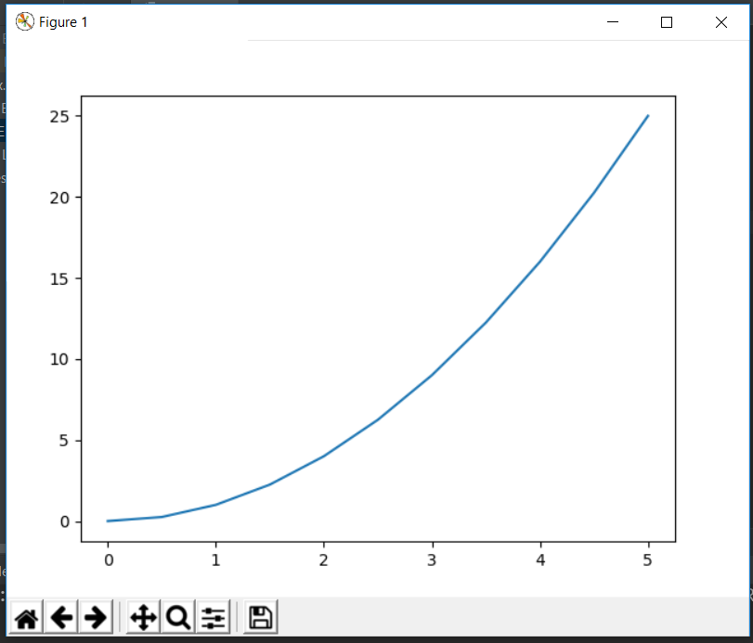

### Specifying labels and title

import matplotlib.pyplot as plt  
import numpy as np  
x = np.linspace(0,5,11)  
y = x ** 2  
  
fig = plt.figure()  
axes = fig.add_axes([0.1,0.1,0.8,0.8])  
axes.plot(x,y)  
axes.set_xlabel("X")  
axes.set_ylabel("Y")  
axes.set_title("Title")  
plt.show()

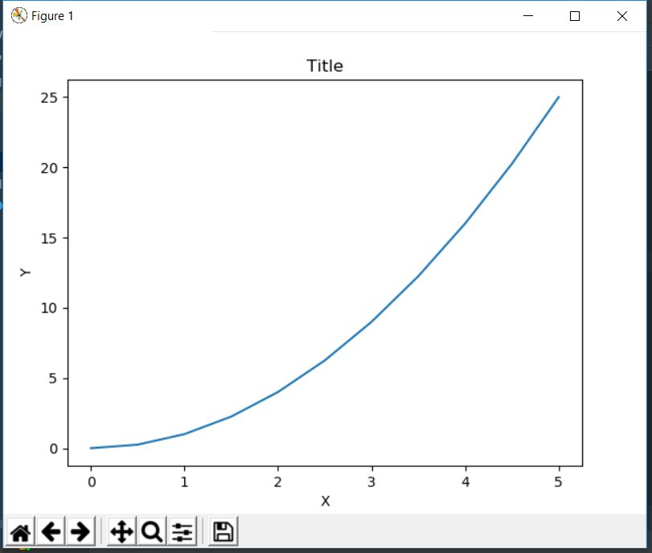

### Creating multi-plots and understanding add_axes() method

import matplotlib.pyplot as plt  
import numpy as np  
x = np.linspace(0,5,11)  
y = x ** 2  
  
fig = plt.figure()  
axes1 = fig.add_axes([0.1,0.1,0.8,0.8])  
axes2 = fig.add_axes([0.4,0.5,0.4,0.3])  
plt.show()

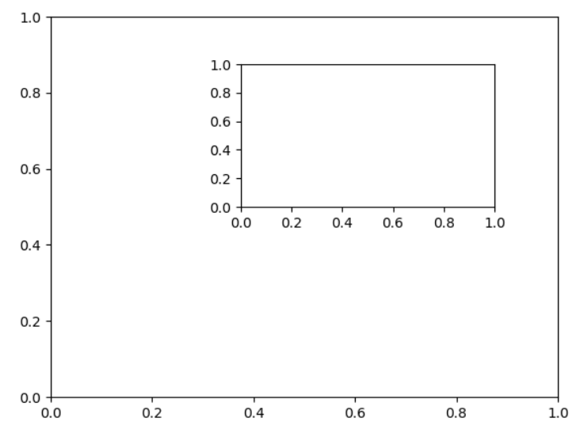

import matplotlib.pyplot as plt  
import numpy as np  
x = np.linspace(0,5,11)  
y = x ** 2  
  
fig = plt.figure()  
axes1 = fig.add_axes([0.1,0.1,0.8,0.8])  
axes2 = fig.add_axes([0.2,0.5,0.4,0.3])  
  
axes1.plot(x,y)  
axes1.set_title("Larger Plot")  
axes2.plot(y,x)  
axes2.set_title("Smaller Plot")  
plt.show()

